*Hugo* and log responses

* Interview with Martin Scorsese from *The New York Times* online

“Martin Scorsese’s Magical ‘Hugo’” By JOHN BOWE, Published: November 2, 2011

**Q: In the past, you’ve gone to great lengths to achieve a desired texture. In “**[**Raging Bull**](http://movies.nytimes.com/movie/40104/Raging-Bull/overview)**,” someone held a hot bar of iron beneath the lens to make Jake LaMotta look particularly weary. In “**[**The Age of Innocence**](http://movies.nytimes.com/movie/119008/The-Age-of-Innocence/overview)**,” when Archer first sees Ellen, you overcranked the camera and then dissolved each frame into the next to make things flutter and slow down. In what ways did you experiment on “Hugo”?**

My instinct was if something wasn’t normally done with 3-D cameras, let’s see if we could do it. And that actually was almost every other shot. But the most enjoyable time was building an approximation of Georges Méliès’s glass studio. We started replicating scenes from Méliès films as best we could. We recreated the underwater set for “Kingdom of the Fairies.” With Méliès’s films, especially the hand-colored ones, it’s like illuminated manuscripts come alive. We shot Méliès shooting his films for five or six days. It was one of the best times I’ve had shooting a picture.

**Q: What made you want to work with 3-D?**

I’ve been a 3-D fan since I was 12, in 1953, and I saw every 3-D film at that time: “[It Came From Outer Space](http://movies.nytimes.com/movie/25499/It-Came-From-Outer-Space/overview),” “[Creature From the Black Lagoon](http://movies.nytimes.com/movie/11478/The-Creature-From-the-Black-Lagoon/overview),” “[Kiss Me, Kate](http://movies.nytimes.com/movie/27525/Kiss-Me-Kate/overview),” which is quite beautiful in 3-D. What I really responded to was the figures, the people in the frame. You have a lot of that in “[Dial M for Murder](http://movies.nytimes.com/movie/13590/Dial-M-For-Murder/overview).” In “Kiss Me Kate,” there’s a shot where Ann Miller moves toward the camera with a fan as she dances. You feel as if you’re onstage right next to her. It’s a different experience, completely. Different from theater, different from 2-D film. It just is.

* Consider the comic below and what it seems to be saying about cinema in modern times, especially given advancements in home entertainment.

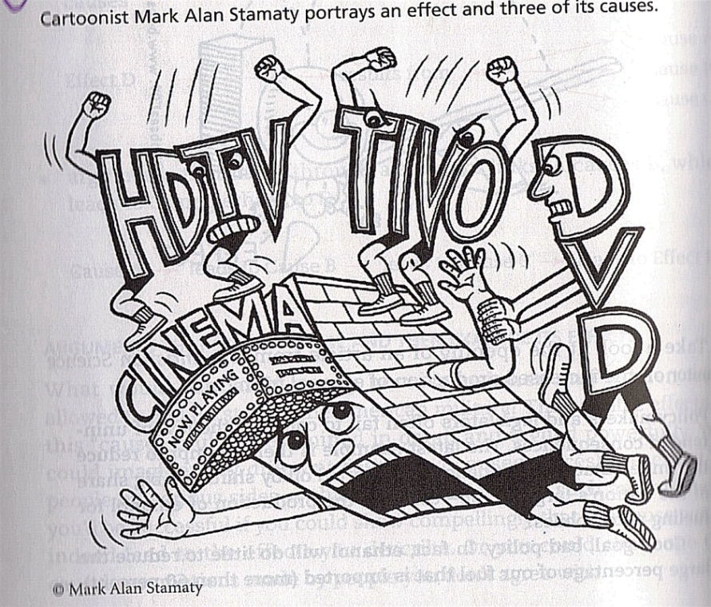

LOG RESPONSES:

**MUST ANSWER:**

1. While the *NY Times* interview excerpt notes Scorsese’s experimentation with film in 2011, the comic is more pessimistic toward film. Referencing either the interview or the comic or both (you may also want to reference *Cinema Paradiso*), also incorporate your own personal observations/opinions about film today: Is it still an evolving art form? Is it relevant to a modern audience? How? Or is it approaching its own demise/death? Defend your choice.

**CHOOSE ONE** of the following two prompts.

1. What about Hugo made you appreciate early cinema more?
2. In the *Hugo* excerpts, how are the automaton and the character of Georges Melies similar?